Helen Best, Dean of Academic Strategy
Version 1 – 1st December 2020
Contextual Implementation Planning and Assurance Reporting for Semester two 2020/21 - guidance and templates
A clear plan for delivery which provides a compelling and supportive offer to students, secures student experience, success, and progression.

Contents
Background and overview 3
Learning from Semester 1 3
Contextual Implementation Planning 4
Resource planning assumptions 7
Organisational enablers in support of the Contextual Implementation Plan 8
Framework for collaboration and oversight 8
Framework for accountability 9
Framework for communication 9
Course Delivery Principles 12
Hallam Model 15
Appendix A - Contextual Implementation Plan templates 16
Appendix B - Supplementary Guidance, Infrastructure Support, other useful information 20
Infrastructure 20
Further guidance and potential considerations mapped against the Course Delivery Principles 21
Other support for students 23
Appendix C - College Summary Report template 24

Background and overview

During Semester 1, and because of the ongoing COVID pandemic, we have experienced significant uncertainty and had to respond by adjusting teaching delivery in line with changing regional and national measures. We have experienced delivery at DfE Tiers 1 – 3, working within the University’s Contingency Framework, and learnt what works well and what works less well. Although people have adapted, and learning has become tacit and more naturally deployed and embedded, constant change remains hard to manage. ​
Providing more stability and a smooth transition between different modes of delivery is essential for students and staff and the remainder of the academic year must feel more planned and coherent (at course level).
We need to develop a clear plan for delivery of the remainder of the academic year that will provide a compelling and supportive offer to students and secure student experience, success and progression. ​

Learning from Semester 1

Our approach to contextual implementation planning needs to be based on what we know and have learned throughout Semester 1. The top 5 observations from a cross-university group looking at this were as follows:

- Students need to feel engaged and motivated. We therefore need to:
- Provide a full and inspiring schedule of activities, whether on-campus or online, to incentivise engagement with learning opportunities and to reinforce time-management skills
- Use ‘big challenges’ to create team cohesion – contributing to community, belonging and social learning
- Create a ‘sticky extended campus’ where students want to dwell. ​
- Students want face to face activities to be purposeful. We need to provide on-campus activities that:
- Use resources not available online​.
- Demonstrate applied learning
- We need to focus on student outcomes. This means:
- Engaging with the Course Delivery Principles ​
- Constant change is hard. This means: ​
- We need to provide stability where we can
- We need to illustrate the path ahead – create a line of sight between now and the end of a successful academic year.
- Supporting students requires timely use of professional judgement in context to ensure we manage change effectively, this means contextual planning is needed.

More detailed learning from Semester one
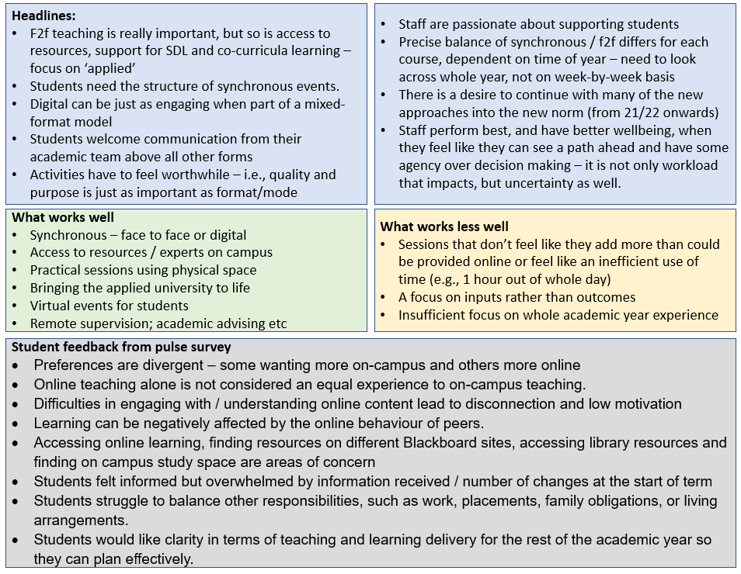

Contextual Implementation Planning
The Contextual Implementation Plan purpose is:
- To optimise the return to on campus f2f delivery, managing the transition between the DfE tiers as smoothly as possible and creating greater stability. ​
- To provide a holistic approach to the student experience over the whole year, not just week by week, providing a pathway to completion or progression that is course specific and meaningful, meeting or exceeding expectations. ​
Having the contextual plans will also help give us the necessary information to:
- To re-ignite motivation in students where engagement is lacking and further engage those students who are already engaged.
- To share expectations, translating staff commitment to student success, reiterating the support offer, and reinforcing students’ responsibilities to manage their time and take advantage of the support offer.
- To communicate frequently about what the learning experience looks like for the remainder of the year. What are we doing more of and what are we doing differently? ​

What makes a ‘contextual’ Plan?
The proposed contextual plans stem from the Course Delivery Principles and are designed to ensure that we are thinking holistically about enhancing and refining a positive student learning experience. By taking a plan-ahead approach, we can identify where / how to enrich the curriculum, offer different learning opportunities, promote the support offer etc. The plans are a means to think about the content and experience across the remainder of the academic year as a whole.
A contextual plan is not the same as a contingency plan. The contingency plans provide details of the format of core teaching or practical experience at each of the different DfE tiers and are semester specific. The contingency plans ensure that we can deliver the core teaching under the different DfE tiers – which in turn can be applied to whatever category of type of restrictions are imposed locally or nationally. They do not typically describe the enriching co-curricula activities or interconnection with different support services.

The contextual planning process should incorporate or reflect: | Plan should bolster engagement, secure successful outcomes and ….
- Local response to deliver excellent student outcomes (experience, expectations, achievements, success, and progression).  - Apply insight and learning from those closest to the student experience, an demonstrate timely use of professional judgement.  - Prompt students to dwell within the extended learning environment (sticky campus).  - Improve and simplify communications to students  - Add value to the learning experience that students can recognise. | - Be student focussed and evidenced based  - Have student needs immersed in the design, development, and monitoring of the plan as partners.  - Offer authentic engagement with students.
- Department level-planning (with oversight at College level) | - Be aggregated to Department level and overseen by HoD.  - Ensure HoD can confidently describe what is happening in the context of their department and what approaches are being used.  - Provide opportunities for collaborative approach across subjects and courses.  - May have sub-sections depending on how the Department works (diverse subject areas).  - Include activities delivered in the context of a course.
- Level of study (e.g. commonality across courses at same academic level). | - Acknowledge the different needs and priorities of students at different levels of study.
- The nature of teaching, learning, assessment approaches and the factors that enable students to successfully demonstrate learning outcomes. | - Manage CMA risk  - Ensure student outcomes are comparable to previous years  - Offer applied learning – supported by the Hallam Model framework.
- Consider the students’ learning experience holistically including activities outside timetabled sessions. | - Provided by professional and student support services, Students’ Union.  - Offer extra/co-curricular opportunities.
- The facilities, spaces, hardware / software required to support and enable successful outcomes. | - Engage and support the development of the specialist skills and applications fundamental to their discipline and sector, supported by relevant central services such as TORS, DTS etc.
- Cohort characteristics which are proven to impact engagement and success (for example, to include commuter, International students, top-up students, BAME students) | - Inclusive practice is at the heart of the plan with activity planned to acknowledge and address barriers to engagement and success

Key elements of a contextual plan
The plans should address:
- How the Course Delivery Principles will be implemented with a focus on student experience and outcomes, within the local context.
- How the local teams will provide a full and inspiring schedule of purposeful activities – building confidence and adding value. The template in Appendix A is designed to support you to do this
- How the local teams will move smoothly between Tiers and back to f2f on-campus delivery as soon as circumstances – we need to recognise the importance and value of f2f on campus delivery and to move to this as soon as circumstances allow. All students must have the opportunity to engage in a compelling on-campus experience throughout the remainder of the academic year.

The plans will likely include:
- f2f teaching​
- access to resources - whether on campus, online, or loan​
- synchronous learning – lectures/seminars​
- social learning activities – peer to peer​
- build a sense of belonging and community​
- support self-directed learning​
- offer virtual events – masterclasses; employer/industry engagement; placements​
- applied learning – specialist estate, linking theory to practice​
- online/remote – supervision; academic advising; technical support​

How to ensure that plans are measurable and support a ‘plan, do, review’ approach
The planning templates will support identification of ‘what’ activities or approaches you are going to use based on success in Sem1 or a desire to do something different. The template will also help you identify how and when these activities will be incorporated.
It is important that we incorporate co-creation and testing of ideas with students, reviewing with professional and support services and academic peer scrutiny. Some of this will be in the design phase and some of it will be through review at key points.
To make reviews effective, whether to improve delivery in-year or to provide assurance to a range of stakeholders that we are delivering a holistic learning experience, it helps to have measurable actions identified within the contextual plan. This means quantifying frequency or specifying timing or people involved so that you can easily identify when something has been delivered, as well as identifying the desired outcomes and relevant measure.
Other key aspects include:
- Building in clear responsibility and accountability for the design, delivery and monitoring of the plan.
- Setting ourselves up to be able to enhance provision as we receive feedback on what works well and as circumstances change.

The templates for Department Level plans and for HoDs oversight of delivery can be found in Appendix A

Resource planning assumptions
The resource planning assumptions for Semester 2 are based on the default position of DfE/Contingency Plan Tier 1, which is the basis on which timetables have been produced. This does not mean that we will be in Tier 1 at the start of the Semester 2. It means we have the ‘tolerance’ in the system to return to f2f on-campus delivery as soon as circumstances allow, by ensuring that we have the ​buildings open and operating safely; 1.2m socially distanced room capacity; timetables (delivering 6 hours synchronous with minimum of 4 hours on campus); and the existing staff resource in place.

Organisational enablers in support of the Contextual Implementation Plan
The Silver Chairs Group will provide co-ordination (both directly and through their respective Silver Groups) for the organisational enablers to support delivery of the contextual plans. This will include:
- Providing a framework for contextual implementation plans and their assurance reporting
- Undertaking employee relations and partnership working with the Trade Unions and with the Student Union
- Working in collaboration with Estates and Facilities to support on campus learning and experience (f2f; social learning; building communities)
- Commissioning timetabling process improvements
- Commissioning ongoing innovation in learning resource support (TORS; DTS; ADev; Digital skills; Employability and Enterprise; learning centre)
- Commissioning advice, guidance, and development opportunities (ADev; Digital skills; T&L; Employability and Enterprise)
- Working with colleagues in Marketing and Communications on the SHU-wide communications (staff and student)
- Collating and sharing findings from student voice activities including links back to 5 and 6
- Refreshing policies and guidance (eg Contingency Plan; CDPs)
- Providing central oversight of key planning activities (AWP; PDRs; timetabling; module choice etc)

Framework for collaboration and oversight
Plans will be developed with the students and the department at the centre (ensuring a strong contextual element), with engagement, co-creation and support coming from the College Leadership Teams, professional services and the organisational governance groups.

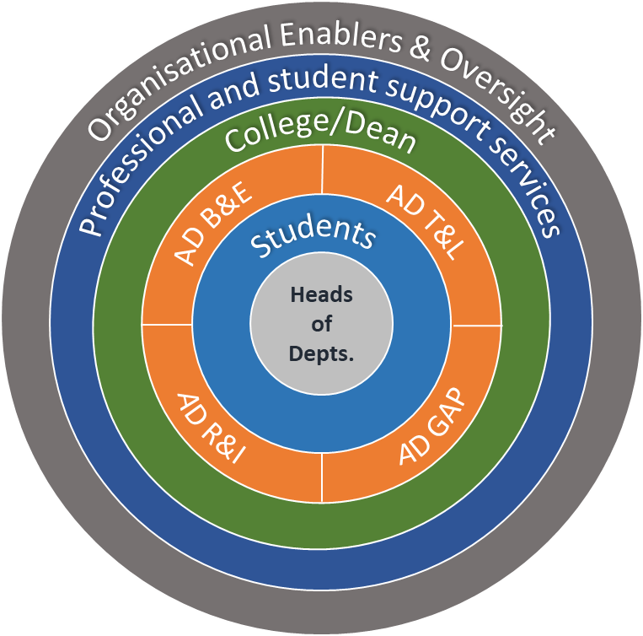

Framework for accountability
Contextual planning is designed to be done at a departmental level. They key accountabilities are as follows:

Role | Accountability
Dean of College | Accountable to DVC (Academic) for contextual delivery across the College being in accordance with the Course Delivery Principles
Head of Department | Accountable to the Dean of College for development and delivery of contextual plans that align to the Course Delivery Principles.  Responsible to the ADTL for provision of assurance reports.
AD Teaching & Learning | Accountable to CDSE (Silver Group) for collation of assurance reports from College

Framework for communication
Effective communication to students at a local level is an essential component of the Contextual Implementation Plan. This needs to begin with effective staff communication. The following provides guidance.

Communications objectives
- To introduce the new contextual planning process to academic staff
- To encourage both engagement with its development, and embedding its implementation, with academic staff at all levels
- To support local communications to students through broadcast/corporate communications, as appropriate

Overarching message

Planning to make a difference
We will provide our students with an inspiring, stimulating, exciting and memorable learning experience at Hallam in Semester 2. From January, we will show our students a clear trajectory to the end of the 2020/21 academic year that gives them a longer view and the confidence that their transition back to face to face teaching will be smooth and we will be clear about how they can be involved in moulding the choices that will help them progress to the next level or completion of their studies.
We want them to see more of what has worked well, and understand what to expect as Covid restrictions change, to know how to collaborate, what facilities are available and what support is at hand. We want them to believe in the power of the Hallam experience and be motivated to be part of it.
We will do this by harnessing the passion, creativity and expertise of our teachers, the knowledge of our course teams, the feedback and energy of our students, and the lessons we have all learnt so far. We will plan locally, share widely, and channel the experience and agility of the whole University community. We are taking a fresh and original approach in our planning - to empower those who know our students best to try new ideas - so we can exceed expectations and make a difference.
The timing is tight – we need to begin our planning now and communicate what is coming to students before the Christmas break.
Support from central communications
We have a range of central channels and an existing communications framework that we will use to communicate the overarching messaging and share the ongoing planning, as below:

 | w/c 30 November | w/c 7 December | w/c 14 December | w/c 21 December
SLG email | 1 December | 8 December | 15 December | 22 December
College newsletters | 2 December |  | 16 December
All staff email | 3 December | 10 December | 17 December | 23 December (TBC)
VC/DVC all staff video | 4 December | 11 December | 18 December | 23 December (TBC)
Academic Digest | 4 December | 11 December | 18 December | 23 December (TBC)
Managers’ Brief |  |  | 14 December
Student Digest | 4 December | 11 December | 18 December
VC all student video |  |  | 18 December

Support with local Comms
Direct communications to students from their academic team is key. Students want, appreciate and engage with communications from their lecturers in a way that cannot be matched by broadcast messaging.
As with the content of your course planning, you should think creatively about how to capture your students’ attention and enthusiasm in the way you articulate your planned Semester 2 course delivery.
Consider what your key messages are and any innovative ways you can convey these.
This part needs further detail/information – we can create template of key messages around student support and resources, practical and technical support pulling together some of the content from the Student Support section above, and also link to the Communications Toolkit and include some creative examples – but also needs to emphasise the local, specific messaging that need to be tailored by course teams.

Course Delivery Principles

The Course Delivery Principles will continue to be used as the core framework to guide delivery of the student outcomes we need to achieve, recognising that this must relate to whole student experience and not only the way we deliver teaching.

​The student learning experience in Semester 2 will continue to be developed using guidance built around four ‘principles’.

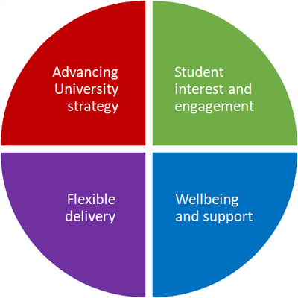
Four principles to support outstanding student experience
Advancing University strategy
Our taught provision should reflect the University’s strategic aims of being applied and striving for distinctiveness and quality. ​​​​​​​
Student interest and engagement
Students are at the heart of our teaching. Courses should be engaging for students from all backgrounds, providing the best opportunities to succeed.
Flexible delivery
Teaching delivery should be focused on successful remote delivery, but plans should be developed for a gradual, phased return to campus as this becomes possible.
Wellbeing and support
Teaching should be embedded in strong support for students and staff.
Following a review of Semester 1 the following two charts indicate what, why and how we can return to the core of the course delivery principles at both organisational and department levels in order to deliver excellent student outcomes.

Course Delivery Principles – Organisational View

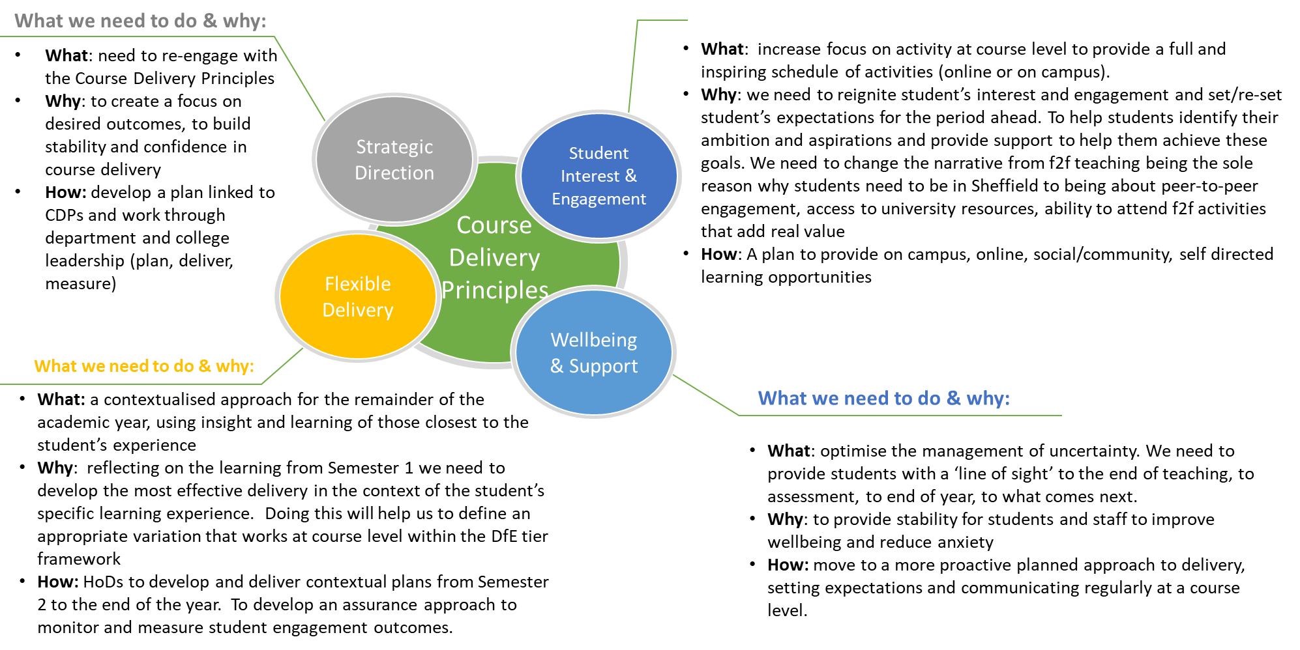

Course Delivery Principles – Departmental View
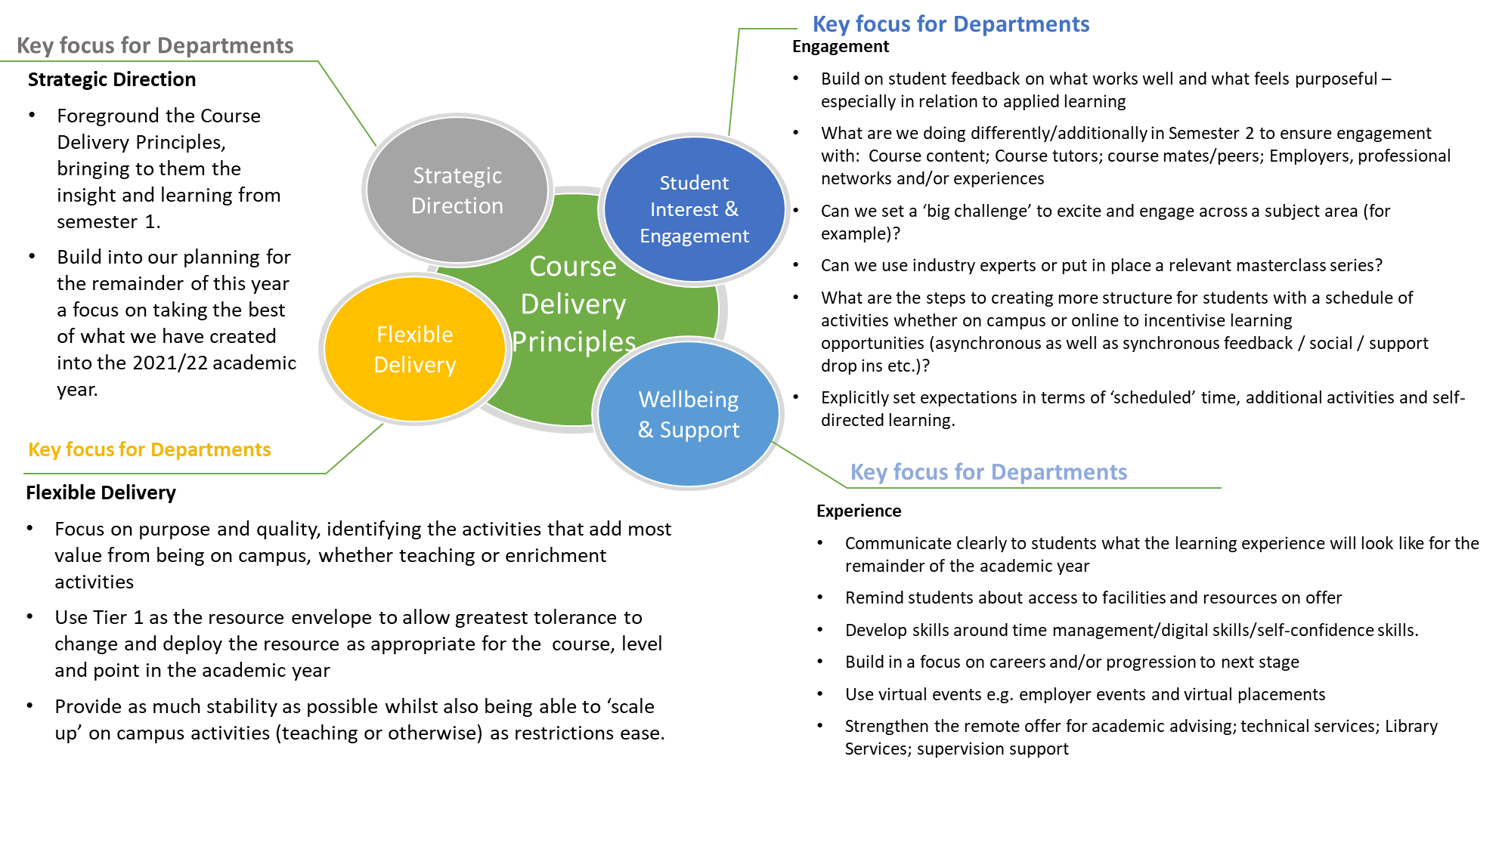

Hallam Model

In addition to the Course Delivery Principles, the University’s curriculum design principles are framed within the Hallam Model and help to ensure excellence in the way we deliver our mission to become the world’s leading applied university. They are simple, clearly expressed and shape all we do. Explore the Hallam Model principles below to see ideas and links to existing programmes that may assist you to be even more creative and innovative in designing your curriculum through the Hallam Model lens. Hallam Model
Engage
Learning engages with the world beyond the university.
Challenge
Learning is intellectually stretching.
Collaborate
Learning with, from and alongside others.
Thrive
Learning enables students to thrive personally, culturally and professionally.

Appendix A - Contextual Implementation Plan templates
Department Contextual Implementation Plan (templates)
Dept:
HoD (owner):
College:

Use the guidance provided to support completion of the plan(s).
Section 1 – Department Contextual Implementation plan
This is the ‘design’ and ‘delivery’, the what and the how.
This is a template to support the development of a plan that aggregates the activity at course and subject level and is to be completed by each department. Sub-sections can be inserted as relevant and where departments are diverse in their subject make up. There is a strong recommendation to include sub-sections by academic level. Courses or Subjects may choose to adopt this template to plan for and guide delivery.
Section 2 – Department Overview
This is the ‘review’ and ‘monitoring’ from a Department and College perspective, leading to assurance reporting.
This is a template to support HoDs and Deans of College to take a retrospective review of progress against the department plans at regular points in time. Deans of College may want to adopt this template to support College oversight. This will guide HoDs and Deans towards regular review and oversight of delivery.
Section 3 - Prompts for discussion and checking effectiveness of the plan

The questions in this section are intended to be useful prompts to enable discussion in developing the plans and overview of the plan. There is no expectation that each and every question will be answered.

Section 1 – Department Contextual Implementation Plan – what and how.
This may be split into sub sections depending on how the Department works (where there are diverse subject areas). Split by academic level of study – acknowledging the common approaches applied at each academic level eg Level 4 – activities to encourage a sense of belonging; Level 6 – preparation for employment. Plus specific activities in the context of the course.
What activities will you do to:  - maintain or increase student engagement; enable student success; provide a compelling student experience? |  | How will you deliver – actions, and to what end?  - What is the expected outcome?  - What are the measures of success? | Timelines | Accountability | Enablers – College; cross institutional support | Review and monitor
What has worked well in Semester 1 that you want to build on/enhance?
1 | Detailed activities delivered in the context of the course | - What is the expected outcome?  - How are you going to deliver the expected outcome? | When | Who | Cross reference back to institutional support | What is the outcome?  What has been achieved?  How do you know? What is the evidence?
2
3
6
7
8
What will you do differently in Semester 2 as a result of student and staff feedback and learning from Semester 1?
9 | e.g. delivery of master classes
10
etc

Section 2 – Department Overview – Review, monitor, assure.
This is intended as a live document to support the HoD in describing the approach undertaken by the department and reviewing effectiveness. It provides the HoD and Dean of College with an overview of activity at regular points in time.
 | Outline of dept approach | Review point(s) - Jan | Review point(s) - Feb | Review point(s) - March | Review point(s) - April | Review point(s) - May | Review point(s) - June | Review point(s) - July
What is working well/less well? How do you know (evidence)? What adjustments need to be made?
How well and how smooth are the transitions between DfE tiers working?
Is the plan to transition to f2f delivery on campus on track? Has it been accelerated/slowed?
Are Course Delivery Principles at the core?
Is the on-campus and digital Teaching & Learning offer effective?
Is the Employability and Enterprise offer embedded?
- HSE
- Placements
- Employer engagement
How well is the co and extra curricula (including engagement with SU opportunities) offer working for students?
Are the planned interfaces and specific intervention points with professional and student support services working effectively?
How well are local student comms working in terms of landing the messages?
Is the timing of the comms right? Is more/less needed and at different times?
Are the touchpoints with students appropriate? Is the approach to immersing students in the plan authentic and effective?
How effectively is learning about contextual delivery being shared?
Have opportunities for a collaborative approach across subjects and courses been implemented effectively?
etc

Section 3
Prompts for discussion and checking effectiveness of the plan
The below questions are prompts for discussion in development of the plan and can act as a checklist.

Local response to delivering a compelling and supportive offer to students and secure student experience, success, and progression.
- What is your approach to delivering a f2f offer as soon as circumstances allow?
- What is the proposal for a smooth transition to tier 1?
- Resource requirements or support required to enable travel out of tier 3 to 1?
- How are you engaging with the course delivery principles?
- What has worked well in terms of meeting student expectations and needs in Semester 1?
- What evidence is there?
- How are you planning to enhance what has worked well to meet student expectations in semester 2?
- What approaches are being used?
- What are you going to do differently in semester 2?
- Are we aiming to achieve something different, if so, what is this?
- How are you adjusting activity at course level to provide a full and inspiring schedule of activities (online or on campus)? What are you doing differently?
- Describe the design of the student’s learning experience. What components are making up the totality of the learning experience for the student? What will the student see, feel, experience?
- Could be linking/sign posting/highlighting existing planned skills centre activity or extra and/or co-curricular offers to students
- How are you reigniting student’s interest and engagement and setting/re-setting student’s expectations for the period ahead?
- Cohort characteristics which are proven to impact engagement and success (to include commuter, International students, top ups, BAME …)
- How are you optimising student learning by engaging in opportunities provided by institutional support services?
- Teaching, learning, assessment approaches and the factors that enable students to successfully demonstrate learning outcomes.
- Describe what is compelling about the student experience being offered in the context of the department? What is it you are doing to encourage students to dwell in the learning environment and to engage in activities?
- How will you communicate the offer and the schedule to students?

Appendix B - Supplementary Guidance, Infrastructure Support, other useful information

Infrastructure

Infrastructure Support | Links to further information | Key contacts
Coordination of key planning activities | AWP, PDRs, TT, Module choice | DVCA
Business Partner Model | provide expert advice on:  TORS  DTS  TT  HR  Finance
Employability and Enterprise | Semester 2 Employability and Transition offer. | Leads - Conor Moss  Contact - Esther Kent
DTS | Dave Thornley summarising the DTS offer for Sem 1 and what they are doing for Sem 2, this week | Leads - Simon Briggs  Contact - Dave Thornley or Andy Roche
Timetabling | Timetabling are taking several steps to enhance both the student and staff experience in semester 2, having reflected on semester 1 delivery. Details can be found here. | Leads Helen Best, Philip Wain and Ashley Hopps  Contact – ATL or Timetabling Hub Manager
Estates | Reopening the Campus | Lead - Dan Ladbrury  Contact: Jon Childs
ToRS | Statement of service  Access to technical Services key dates | Lead - Richard Cutting  Contact: Technical Manager

Further guidance and potential considerations mapped against the Course Delivery Principles

Advancing University strategy
Hallam Model Principles Website | you have explicitly aligned the course to the Hallam Model Principles of Engage, Challenge, Collaborate, Thrive?
Flexible Sandwich Placements | you have embedded the delivery of work experience / placements in your course?
Highly Skilled Employment Principles | co- / extra-curricular activities / Field Trips / have been planned and risk assessed in light of COVID-19
Web Accessibility Guidance | learning opportunities will meet web accessibility legislation and be inclusive and accessible to all students?
Support for online Delivery | staff are engaging with the staff development opportunities on offer to support delivery?
Academic Development Sessions | peer-review of the teaching will take place within the different models of delivery planned?
​​​​​​​
Student interest and engagement
Planning and Delivering Blended Learning guidance | on-campus activities have been identified via Academic Timetabling Leads?
 | you have worked with TORS to maximise the use of specialist teaching space within social distancing guidelines?
 | all students will have all their teaching and learning activity timetabled (including independent learning and study and additional opportunities for face to face support)?
Learning Groups | students can be allocated to the same learning group for all the modules on their course?
Student Engagement | you have built into your teaching delivery models activities to engage students with their learning?
Online sessions | ‘live’ learning sessions will be recorded and made available to students via the relevant blackboard site
Library Learning Resources | reading lists will be updated and resources digitally available to students at the start of semester 2

Assessment | adjustments have been made for online delivery of assessments including any S2 online exams?
 | assessment guidance for S2 will be available to students at the start of the semester?
 | your delivery model includes formative assessments to support student engagement and learning?
Inclusive Practice | you have considered the equality impact of your teaching delivery on diverse student groups?

Flexible delivery
Course Delivery | your approaches to learning and teaching are well-suited to the combination of on-campus and online learning?
 | all teaching activity can be delivered online if necessary?
 | students (including those in vulnerable groups) who are not able to attend campus sessions will have the opportunity to engage with the learning opportunities and resources remotely.
CMA guidance | the modifications and/or simplification you have made to your courses are consistent with Competition and Markets Authority (CMA) guidance and include plans to communicate changes to students?
 | all the PSRB and regulatory requirements for delivery and assessment will be met?
Flipped Learning | all lectures to large groups will normally be delivered asynchronously as pre-recorded videos in ‘bite-size’ chunks and available on-line?
Staffing Resource | your course delivery is sustainable within standard AWP allocations

Wellbeing and support
Hallam Welcome Digital First framework | welcome activities will build community and help students navigate their learning environment?
Hallam Digital Skills | welcome activities will support students to develop their digital learning skills?
Academic Advising Essentials | students will know how to access support from their Academic Adviser, Student Support Adviser and Employability adviser?
The Skills Centre | support for ‘return to learning’ will be in place through Academic Advisers and Student and Academic Services?
Support for online Delivery | colleagues are aware of professional development they can access to improve or enhance their digital proficiency?
Hallam Guild | colleagues are sharing best practice and ideas with each other either through local or Hallam Guild communities of practice?
University Guidance | How confident are you that risk assessments due to COVID-19 are in place, and staff understand their roles and responsibilities in implementing these?

Other support for students

Social and Extra Curricular Offer – Winter 2020/1 | Leads - Nick Woolley / Claire Gandy
Gold paper - Assessment support offer 20/21  MyHallam Assessment Support information - - For detailed information, guidance and support regarding assessments | Lead - Neil Mckay
MyHallam information – Student support | Leads - Claire Gandy, Mellissa Jacobi, Esther Kent
Students Union Student Support Sheffield Hallam Students' Union - Home | Lead - Andrew Adegbola -
The skills centre | Lead - Nick Woolley

Appendix C - College Summary Report template

INSERT TEMPLATE

