Portfolios in visual meetings

supporting digital & techology apprentices in a virtual classroom to build e-portfolios for end point assessment

Aim
To provide pathway specific workshops to support learners to develop the content of their e-portfolios in preparation for End Point Assessment, enabling comparison of good supporting evidence, validating Apprentice progress to support confidence in their further preparation and execution of the EPA methods.

approach
A week of sessions was planned, with each day dedicated to a cohort on a different pathway of the digital and technology solutions apprenticeship (e.g. Software Engineer, IT Consultant, Cyber pathway etc.) Each session was already timetabled as an on-line delivery before lock down, but the work still had to be done!
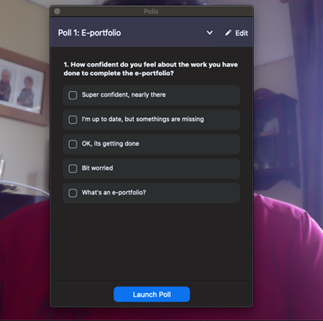
Key elements of the session design would be:
- Reflective Practice to evaluate experience to generate critical evidence of competence
- Gap analysis and action planning
- An action focussed curriculum and assessment brief, underpinned by relevant academic reference points (e.g. Kolb)
- A outcomes-focussed project initiation document
- Use of break out discussions - idea exchange
- Interactive whiteboard for dialogue and capture and responsive re-focussing
- Polls to inform Tutor of confidence levels and next interventions

Benefits
- This is an essential element of gateway / EPA preparation
- A workshop approach is efficient and facilitates sharing of exemplar evidence and peer learning through collaborative inquiry and discourse
- Involvement of the WBL Coach aids insight into apprentice issues and opportunities and ongoing support in Apprentice Progress Reviews (APRs)
- Collaborative tools creates on-line resource for future review / flexibility re engagement (Keep an eye on attendance for audit!)

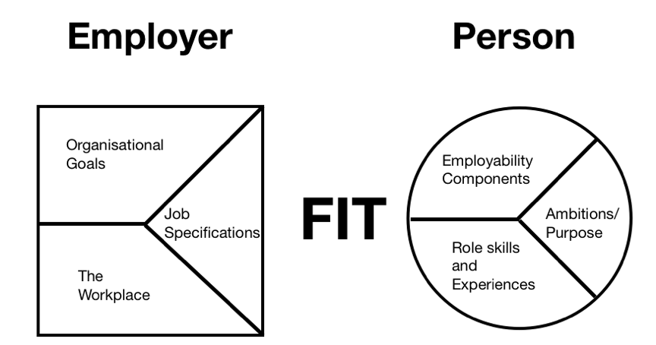

Future Developments
The approach under development takes reference from the reality facing businesses, organisations and individuals in the work place. The drivers include globalisation, with distributed teams and increasing patterns of flexible employment; the pace of change and agile approaches to project delivery; and innovation management- expressed as design thinking for user experience.
The impacts of a visual meeting approach for Apprentices will only be clear through feedback tools (e.g. polls) built into sessions and follow up via coach or formative submissions. The ultimate test will be the impact on apprentices' preparation for EPA and outcomes from the assessment, though of course one EPA Workshop is just one factor within a three year journey in a job role and at University.

Recommendations to Other Staff

- Explore free software and seek to deploy that within the meeting space. Find something you like and request and then check a free educational license
- Make sure you offer gradual introduction and opportunities to check the installation, allow dry runs and manage the user experience.
- Options for team communication include Zoom, Hangouts, Slack, etc….
- for Project management – Jura boards, Kanban, Trello…
- For visualization try Mural, Miro

further and related information
Key Reference points:

Useful l

Key Platforms | Andragogic Impact (including WBL)
 | Laurillard learning activities
Platform 1: | Acquisition | Inquiry | Discussion | Practice | Collaborate | Production
Bullseye: to uncover weak KSB evidence: | 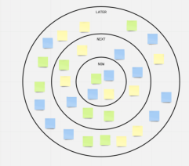  Contact Andy Hirst for further information on impact
Platform 2: | Acquisition | Inquiry | Discussion | Practice | Collaborate | Production
Miro Empathy map: | - Used to elicit and uncover thoughts and feelings  - Used in Design Thinking Methodology  - Example of a visual meeting: https://miro.com/app/board/o9J_kprVJqU=/

Profile
Tutor name(s): Andrew HIrst
College: BTE
Size of cohort: Circa 20
Key themes: Digital Technology; On-line; work based learning; Portfolios; gap analysis, andragogy; Gaeway; End Point Assessment; Visual Meetings

