Degree Apprentice Occupational Therapy

CreativE Group Work - adapting to an on-line delivery

Aim
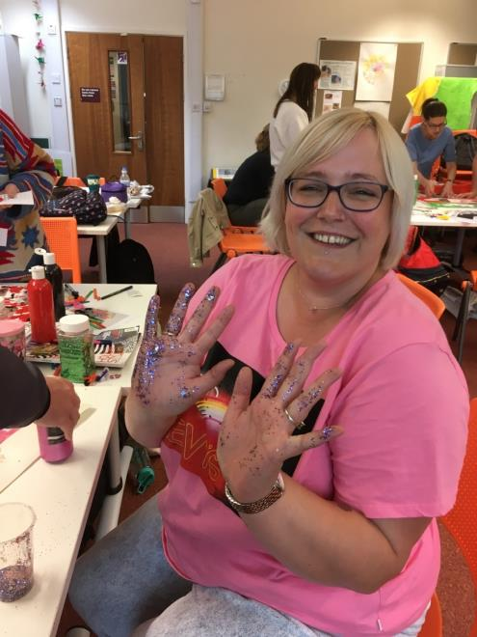
The entire module was due to be delivered face to face within four intensive days towards the end of a two-week block. The aim was to deliver a combination of theoretical principles relating to the role of creativity and group work in supporting health and wellbeing. Delivery would include opportunities to engage in practical experiential activities, using reflection as a core learning tool. This would prepare apprentices for a group-work project back in their workplaces.
Students engaging with the module in 2019
This case study deals with the transition of that trench of learning to an On-line mode, during Covid lockdown, so apprentices had varied, or no access to the work place as a source of inquiry and learning.

approach
Instead of classroom based creative exploration I encouraged the students to do this in their own homes, either on their own or involving family members.
The Occupational Therapist seeks to empower the client to take control over their own recovery and work towards their treatment goals. In an educational setting this could be best described as constructive alignment; firstly that learners construct meaning through relevant exploratory learning activities and secondly that the educator sculpts the learning experience ensuring that the environment, the methods of teaching and assessment all align with the learning outcomes. In addition, by using an engaging pedagogy the students were able to actively participate in the problem-solving elements of the learner process. I believe that we were able to use this crisis to demonstrate the potential skills of the educator to create virtual learning environments which not only continue to follow the learning outcomes but which stretch our student’s imaginations and skills beyond the ordinary. I was blown away by the range of creative ideas, the sharing, learning and development they displayed over the four days and I have promised that when we eventually all come together face to face we will get the glitter and the glue out and celebrate being creative as a whole again.

Benefits
I was very keen that the virtual learning should be seen as an asset rather than less effective solution to a problem. For example, the use of an Intelligent pedagogical approach, in this instance using the Google Community, enabled the students to share material across groups through virtual collaboration, something which could not been achieved without the use of technology.
By learning from their own experiences and building and developing on the skills of others this became experiential learning with the addition of loop input to reflect, discuss and consolidate learning.

Future Developments
One of the core themes we teach within the creativity and group work module is flexibility and reflexivity; being able to break down activities/tasks/occupations and adapt these to the needs of others and the demands of the environment. I was able to not only share my experiences of this from a clinical perspective, but I and the other lecturers were able to demonstrate modelling behaviours (as found in the Apprenticeship Standard) by adapting our teaching to this strange new virtual world. Gone was the safe familiarity of the teaching room and the abundance of craft supplies, we now had to inspire the students to raid their homes and gardens for creative materials and be self-motivated to be creative in very restrictive environments. There is scope to reflect on how these demonstrative elements might be harnessed in future delivery

Recommendations to Other Staff
- In any profession you have to expect the unexpected - Be prepared to demonstrate the agile and reflexive behaviours you are asking of your learners.
- Read the Apprenticeship Standard and identify which knowledge skills and BEHAVIOURS you are exhibiting during delivery.
- With persistent planning and agile delivery methods on-line delivery can support the same learning outcomes with gains and losses to discover,

Further & Related Information

Key Platforms | Andragogic Impact (including WBL)  Laurillard learning activities
Platform 1: | Acquisition | Inquiry | Discussion | Practice | Collaborate | Production
Adobe Spark | I decided to introduce the module by providing the students with an inspirational adobe spark including pictures of them engaging in meaningful occupations they shared prior to the start of the module. This was to make them feel included and reinforced that we were all in this together.
Platform 2: | Acquisition | Inquiry | Discussion | Practice | Collaborate | Production
Blackboard | The Appendix details the original timetable and the emphasis on facilitation group collaboration and reflection as key approaches for the work based learner.  I also redesigned the entire blackboard site and daily timetable to set clear daily tasks for them to follow within the flexible structure.
Platform 3: | Acquisition | Inquiry | Discussion | Practice | Collaborate | Production
Google Community  Powtoon | The students were already using this platform and I felt it was perfect for remotely sharing pictures, videos, ideas and comments.  I also drew from the experience and skills from my colleagues who provided videos and exercises for the students to engage with during the week and I included a range of creative videos such as a PowToon on groupwork.

Profile
Tutor name(s): Beth Sidaway
College: HE&LS
Size of cohort: Circa 20
Key themes: On-line; work based learning; WBL Projects, supervision, work planning; andragogy; leadership and management.

Appendix

This was the original session plan for the groupwork morning. However, it was delivered the week before alongside students from another occupational therapy course. The session was reduced to 2 hours. The theory was taken out and provided in screencast form. The Padlet was not used to reduce the number of digital platforms being used to just the Google Community. The activities were adapted to make the quicker to complete and the personal reflection was encouraged to be completed outside of the session.

Session Plan template
Date: | 24.03.20 | Time: | 9am |  |  | Duration: | 4 hours
Room: | F205/206 | Level: | 4 |  |  | No. Of Students: | 23
Programme(s): |  | Degree Apprentice Occupational Therapy
Module: |  | Creativity and Group work
Topic: |  | Introduction to group work
Session aims:
- To introduce the theory and practice of facilitating group activities with service users
- To provide the students an opportunity to engage in and reflect upon a group activity.

Specific learning outcomes: (At the end of the session, students will be able to…) |  |  |  |  | Assessment method(s): how each learning outcome will be assessed during the session
- To understand the principles and processes of group work  - To start to explore the complexities of group dynamics  - To reflect on your own therapeutic use of self within group activities |  |  |  |  | 1. Question and answer during theory presentation  2. Group discussion asking students to draw on past knowledge  3. Personal reflection
Previous knowledge assumed:
Pre-reading and screencast provided and encouraged prior to session.
However engagement with all of these things is not assumed and summarising the key points will be required.
Resources: (with reference to technology-enhanced learning where applicable)
Access to screencastomatic prior to session
Access to learning material for lecture on Blackboard at least 48 hrs prior to session
During the session access is required to PowerPoint slides, flip chart paper, white boards, art materials and other group activity resources, including handouts.
Notes re: differentiation, learning environment, learning contracts
The power point slides, blackboard materials and creative materials are diverse to suit all students in the group. A range of teaching methods will be employed to ensure that all learners can contribute.
Study skills development:  Soft skills,  Engagement, creativity, awareness of self and others, confidence, team working, reflection. |  |  |  | Hard skills,  Familiarisation with partaking in group work.  Literacy; communication;
Health & Safety
Room layout accessible for wheelchair.
Layout of room to maximise movement and limit trip/fall hazards.
Evaluation (how the session will be evaluated by students, how feedback is managed):
Ongoing facilitation of feedback by teacher via open questions and group discussion.
Use of flipchart feedback at the end of session.
Prior action needed / other staff involved:
Learning materials available and gone through with previous lecturer for session and course leader.
Resource materials and PowerPoint presentation released to students 48 hours prior to session.
continued overleaf
Time | Content/Topic | Student Activity | Teacher Activity | Link to learning outcomes
9-9:10 | Pre-session activity | Prior to session starting, students are invited to continue to upload pictures onto Padlet from previous session. | Signpost to black board site link | 3
9:10-9.30 | Introduction & Ground rules | Listening and actively engaging in developing ground rules for the session. | To explain the aims and objectives of session and to facilitate a discussion around ground rules. | 1,2,3
9:30-10 | Icebreaker | Students are invited to act as facilitator for their group and lead a pre-planned icebreaker task. Each group will provide a brief feedback. | To explain the activity and provide a choice of pre-planned ice-breakers. | 1,2,3
10- 10:20 | Group task | Students are asked to discuss in twos types of occupational therapy group activity, before feeding back to group. | To illicit ideas from the different groups, adding to any gaps in knowledge. | 1
10:20-10:45 | Theory presentation | Listening and actively engaging with discussion. | To present via PowerPoint and recap on the information provided in the screencast. Use whiteboard to assist with learning more complex ideas and use handouts to provide examples of theory in practice. | 1,2
10:45- 11 | Break |  | To set up main group activity
11-11.45 | Main group Activity | Students are asked to nominate another facilitator. The facilitator will choose an activity from the suggested activities provided. They will then lead the activity with their group | To provide an instruction sheet on the activity. To support the facilitators if required. | 1,2
11.45- 12:15 | Group Reflection | Students are invited to spend some time reflecting on the different activities. They will reflect on their role as a facilitator and as a group participant. They are also invited to reflect on the facilitating style of their peers and what they would have done differently. | To facilitate a group discussion about their thoughts and feelings from the session. | 2,3
12:15 – 12:30 | Theory presentation - endings | Listening and actively engaging with discussion. | To present via. Use whiteboard to assist with learning more complex ideas and use handouts to provide examples of theory in practice. | 2,3
12:30-12.50 | Personal Reflection | Provide quiet time for students to write their own personal reflections, both on the role they played and the | To provide reflection tools in a handout . To then encourage self-directed reflection. | 3
12:50-12:55 | Feedback | Students are encouraged to write feedback on post-it notes and add to a flipchart poster on their way out. | To provide post-it notes and flipchart paper and pens. | 1,3

