# *preservation*- engaging learners in food packaging

## online lectures and creative seminars using artefacts from the home for work based learning in the Packaging professional apprenticeship

# Aim

The case study looks at a snapshot of delivery, tackling the theme of containment and preservation of food in packaging. This block of delivery exemplifies how different techniques and learner-centric activities are combined to ensure maximum engagement.

# approach

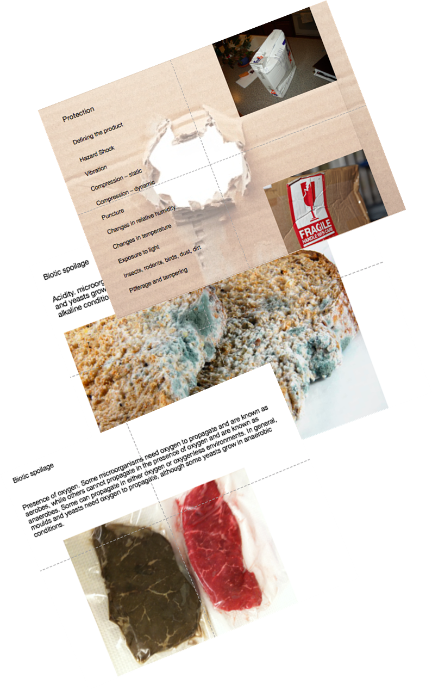The case study includes several techniques:

* Setting clear objectives in respect of participation to address the challenge of passive attendance
* Building on patterns of text-based "chat" communication to strengthen interaction
* Harvesting feedback on engagement using on-line tools, including upload of worksheets from project teams
* Creative use of everyday products in the home to link to work-based themes in the packaging industry
* Providing clear project timelines to support and motivate apprentices

**

***Artefact:***

**Preservation Workshop**

**Tuesday 5th May 2020**

|  |  |
| --- | --- |
| Your Name |  |
| Food Item |  |
| Brand Name |  |

|  |  |
| --- | --- |
| What is the food product? |  |
| What microbiological spoilage is likely to take place with this product?  Biotic?  Abiotic?  Why? | |

|  |
| --- |
| What are the main causes of spoilage (in respect to the answer above) |
| Please refer to the lecture content (there may be more than one) |

|  |
| --- |
| How does the packaging/containment reduce this risk for each of those mentioned above? |
|  |

|  |
| --- |
| With respect to microbiological spoilage what printed information is important and why? |
|  |

|  |
| --- |
| What external factors could spoil the product? |
|  |

# Benefits

Using a range of techniques in careful combination has achieved a consistent goal of securing engagement across a cohort. Despite lockdown impositions the learners have been able to explore the materials and products found in their homes, but which also that shape their on-going careers. Despite Covid-related restrictions they have engaged in peer to peer review of their knowledge, develop analytical and team working skills and explore collaborative and inquiring behaviours - aligned to their apprenticeship standard. This can maintain a growth mind-set and enable acceleration across a wider range of KSBs when work place attendance resumes.

# Future Developments

**

It will be important to review the overall feedback on the innovative approaches explored. Ideally the benefits of on-line innovations can be retained and merged with previous preferences for delivery strategy. Module Evaluation will play as big a part as ever in this development, however this will be an ongoing process in consultation with both leaners and employers through wider three-way review processes and quality enhancement tools.

# Recommendations to Other Staff

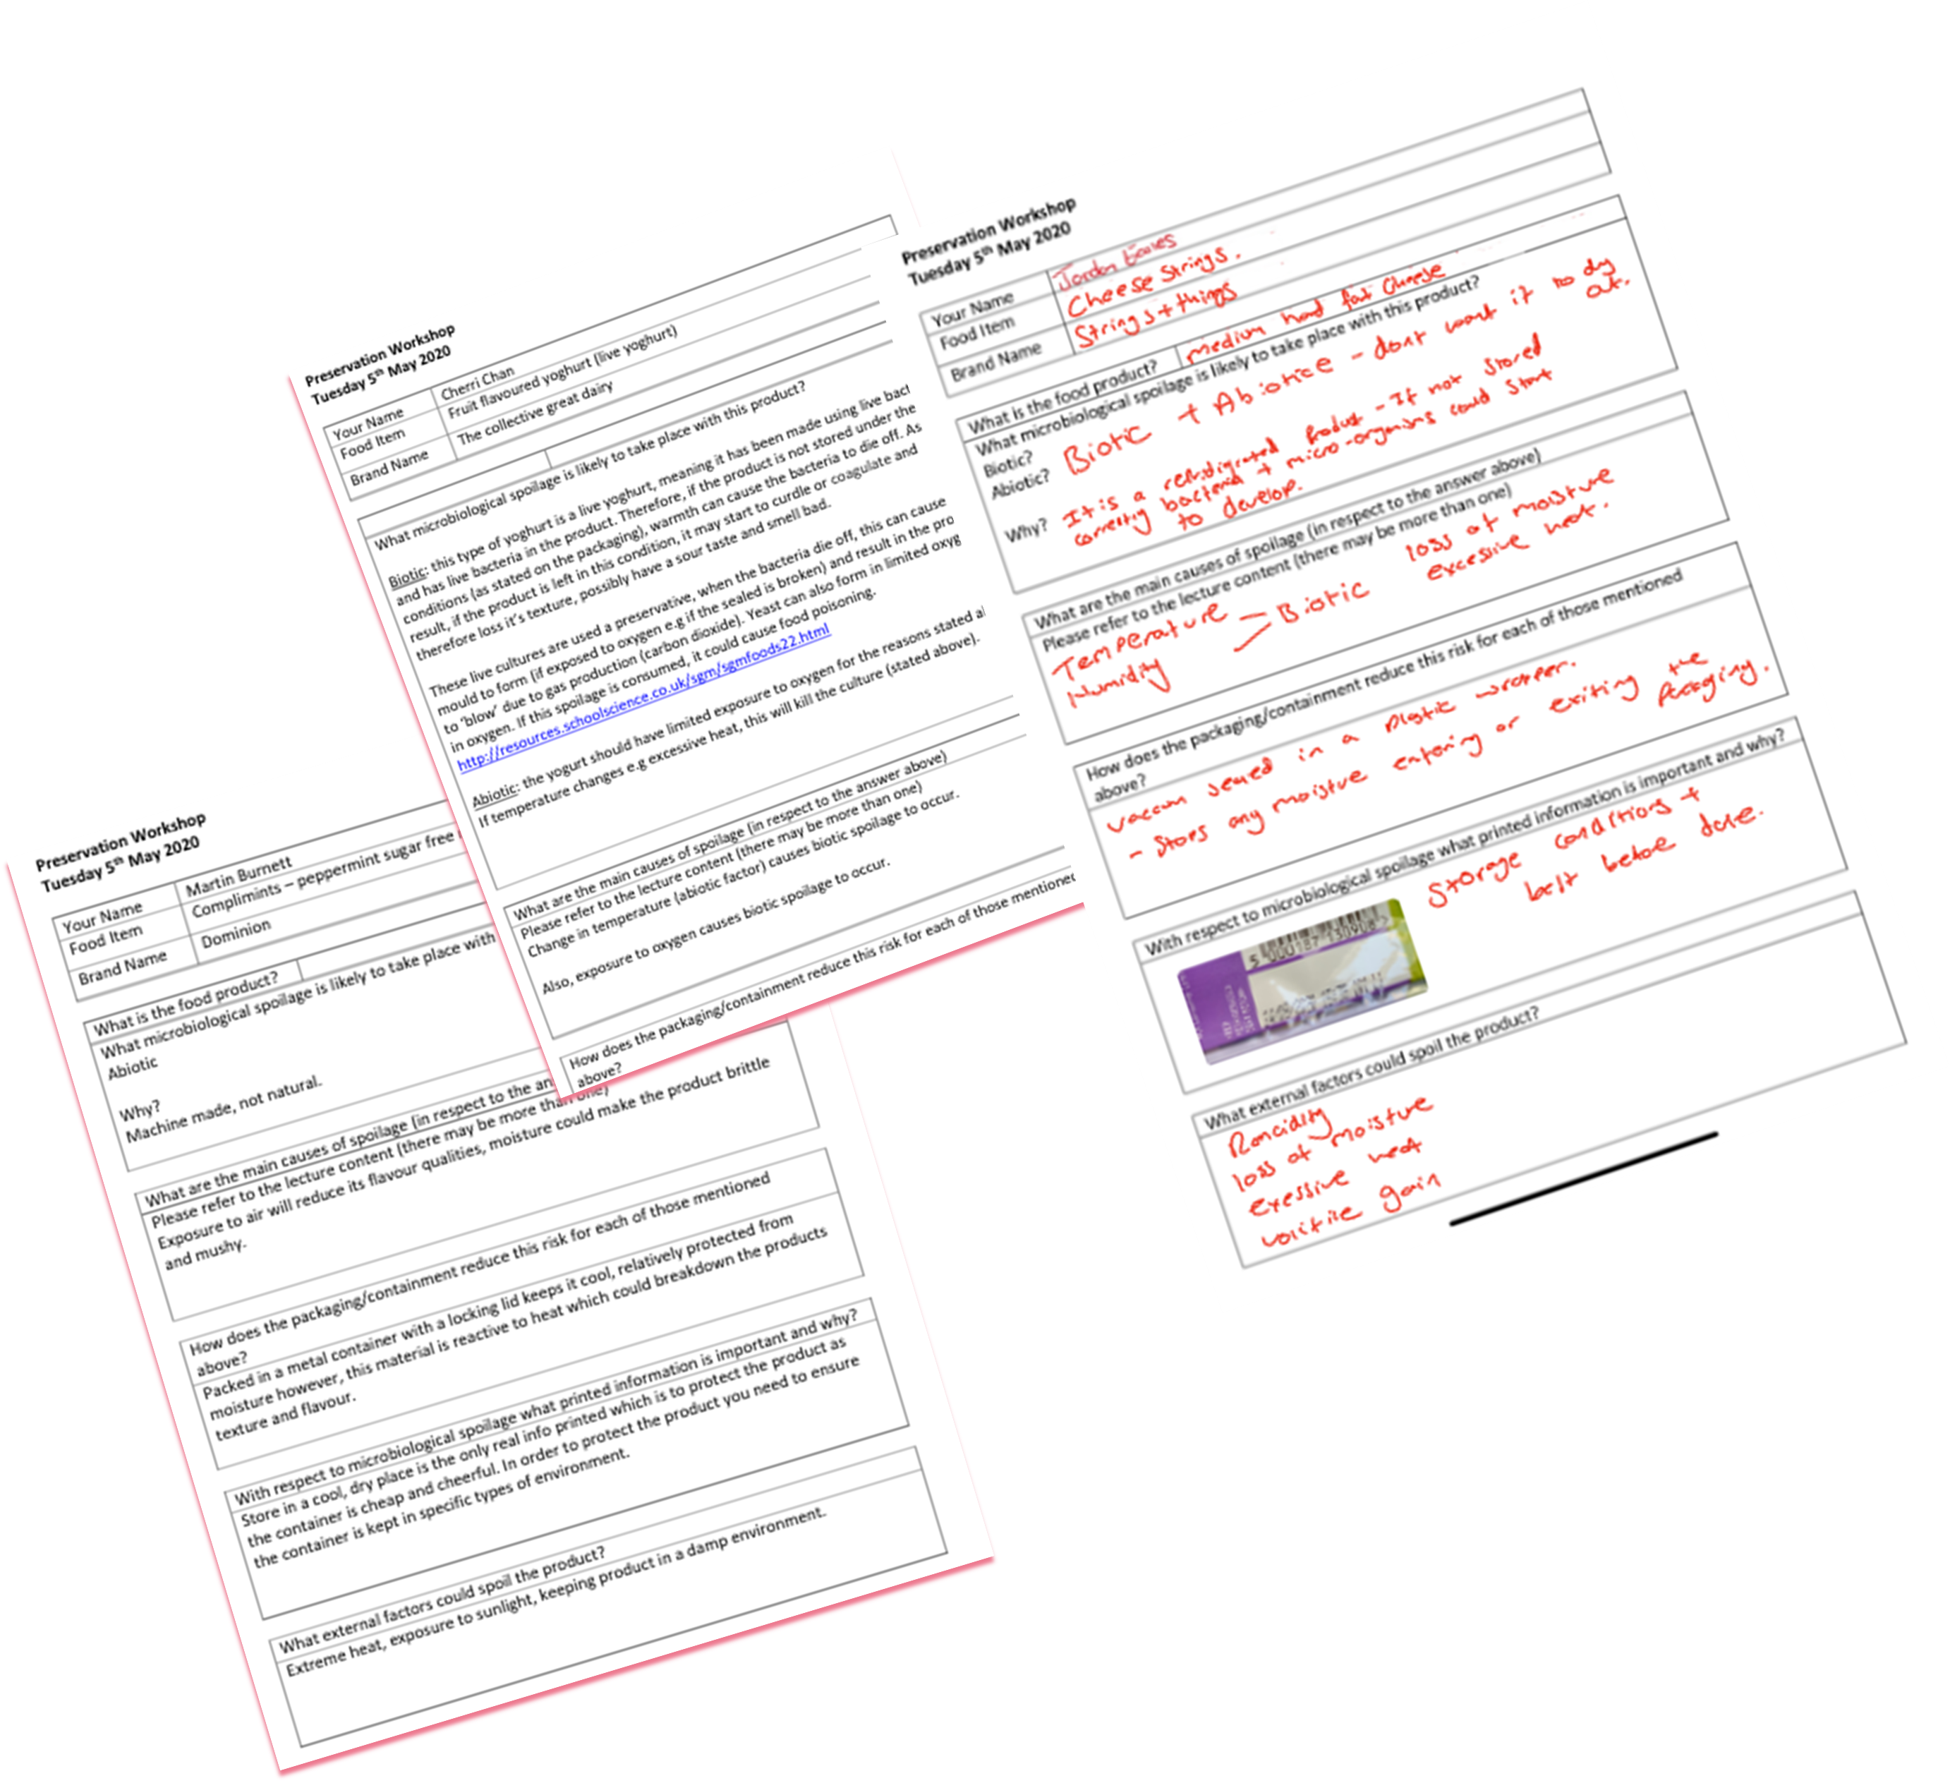Capture learner feedback in creative ways including quick uploads, using blackboard wikis and other basic functionality to create a series of formative feedback stepping stones.

Try driving conversations with zoom chat and capitalise on text base engagement to open up cohort-wide enquiries. Quieter students can trigger the conversations and gain confidence.

# Further & Related Information

|  |  |  |  |  |  |  |
| --- | --- | --- | --- | --- | --- | --- |
| Key Platforms | Andragogic Impact (including WBL) | | | | | |
|  | [Laurillard](https://shu.primo.exlibrisgroup.com/permalink/44SHU_INST/at0fmn/alma99470140602501) learning activities | | | | | |
| *Platform 1:* | *Acquisition* | *Inquiry* | *Discussion* | *Practice* | *Collaborate* | *Production* |
| *Blackboard* | Simple use of basic wiki, and upload functionality in Blackboard can create a clear path for engagement and informal feedback stream to maintain engagement.  This is effective when the intentions and expectations are clearly laid out, for example a basic Ghant chart, or flow diagram to schedule the activities and manage expectations. | | | | | |

# Profile

Tutor name(s): Glynn Hawley

College: SSA

Size of cohort: Circa 20

Key themes: On-line; work based learning; WBL Projects, supervision, work planning; andragogy; leadership and management