Employer Toolkit for your Apprenticeship Training Plan
This document helps you work through ten steps for initiating your Apprenticeship Training Plan. This is part of your commitment as an employer and you should have an initial plan in place at the start of the apprenticeship. Therefore, this toolkit represents best practice to address your commitment, but you may also use your organisation's preferred template.
Work through each stage based on a discussion between yourself in the role of mentor and the apprentice. Do this collaboratively and to the best of our combined knowledge and understanding, but be prepared to skip any gaps, noting the necessary actions for you or your apprentice to return to.
Enhance and adapt this plan as you progress through your apprenticeship. The Apprenticeship Progress Reviews with the Work-based Learning Coach from Sheffield Hallam University will help to agree actions, to keep the plan fresh and support progress towards the apprenticeship End Point Assessment.

Section 1 - Skills Scan Review As part of the application and on-boarding process your member of staff (the apprentice) completes a skills scan. The purpose of the Skills Scan is to establish the starting point of learning for the apprentice (see our on-boarding guidance for more information).
Discuss with your Apprentice their existing levels of competence (knowledge, skills, behaviours) as set out in their "Skills Scan".
Confirm your overall views in the grid by highlighting the box

...You can double click in a cell and then use the toolbar to fill it green - highlighting your answer in this grid: | We agree that most areas of competence are at an early stage of development, so must plan broadly | There are some areas where existing competence is already partially developed so will prioritise the weaker areas | We agree that there are now specific clusters where we can already focus training needs on identified gaps
Knowledge
Skills
Behaviours

Section 2 - Existing Training Identify existing training opportunities for the role and area of work within your organisation

(Like before, highlight where training opportunities exist / or might need introducing by adding colour).
YES | You can change, or add to the text in the second column to suit your organisation...
No | - also, if we have missed anything, just add a new row

Date: | Existing Training / Opportunity
 | Existing corporate induction
 | Existing and available information about the employer organisation, its heritage, missions, aims (etc.) and position in sector
 | All key documents including policy and practice guidance, any key manuals that the employee (apprentice) needs to review and respond to
 | Training for safe operating practice / confidentiality / systems and processes
 | Any shadowing opportunities
 | Internal, or other placements
 | Rotation schemes (existing or new)
 | Ongoing and likely activities with key clients etc.
 | Any known change projects, for example: Identified planned reviews of company policy and practice / toolkits / Implementing new systems and process / other
 | Links to external bodies / networks that will shape the training plan & objectives
 | Typical CPD opportunities for the company and sector / profession

Section 3 - Existing Training and links to Knowledge Skills and Behaviour (KSBs)

In this section, attempt to map the planned training activities (from step 2) to the KSBs that the apprentice must attain. An effective approach will be to populate the KSB Mapping Grid in your Commitment Statement. This already shows the relationship of modules to the KSBs and so you can populate the spare column (“employer activities”), by inserting the planned training activities to build up a picture.
You will receive that grid as part of the Commitment Statement sent to you by apprenticeships@shu.ac.uk

Illustration of how to use the Commitment statement to begin to map existing your existing training to the requirements of the Apprenticeship:

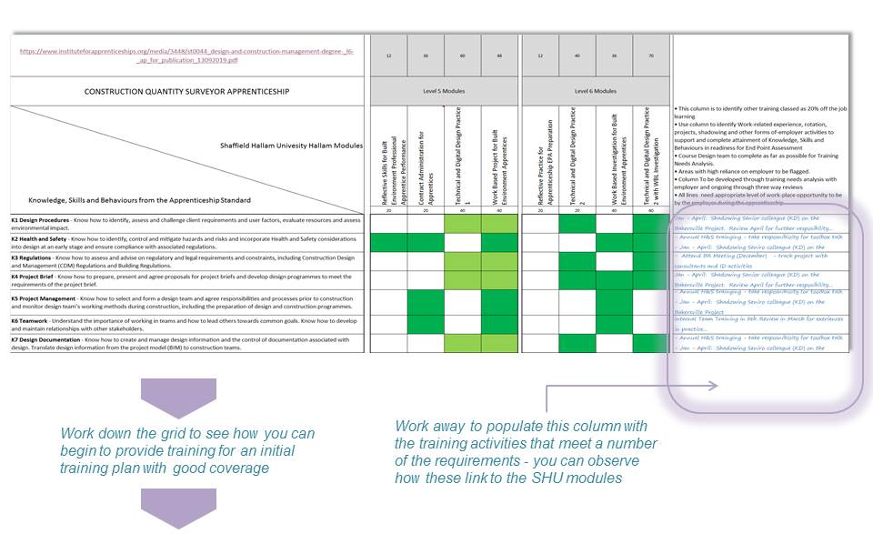

Don’t worry if this activity raises some questions - Use the space below to make any notes, or log any questions to raise in the first Apprentice Progress Review with the SHU Work Based Learning Coach.

Type here…

Section 4 - Initial Project The Apprenticeship must include work-place projects. These should be live projects that develop or support the business and enable the apprentice to develop with increasing impact. Familiarise with SHU Project assessment requirements (year 1 initially). You should have received an outline of the course content and modules. Identify any project based assignments that the apprentice must conduct and submit in year 1. Use the space below to outline what activities will be available in the workplace to meet the requirements. (Note - you can get further information by attending the Welcome Evening to explore this further with the Apprenticeship Course Leader)

Type here….

- Draft Project Title:

- Area of Business / Organisation:
- Start date:
- End Date:
- Key Milestones:
- Key Stakeholder(s):

Key Objectives
- 1
- 2
- 3

Section 5 - Initial Project Scoping Once you have agreed a project idea, you can check and amend the idea using this set of scoping questions to identify the strengths and weaknesses of the proposal and begin to support preparation. Be realistic about what can be achieved at the beginning of the apprenticeship - you might need to focus on the learning at this early stage... On the other hand the project might take place towards the end of the apprenticeship in which case be clear on the impact for the organisation and critically - any relationship with the requirements of the End Point Assessment.

 | Not true | Don't know yet | Agree to some extent | Mostly agree | Completely agree
The project activity fits well with the timescale of the SHU assignment
The apprentice is interested in the project
The Project will work well to support the module learning outcomes
The project activity aligns well with the Apprenticeship Standard (e.g. the KSBs)
The Project is manageable and definable within the timescales
The resource dependencies are realistic
There are clear stakeholders and we can assume support
There are identifiable organisational benefits to the project
The benefits and impact can be measured in some way
We have checked if and how the project relates to the End Point Assessment

Note. The SHU Apprenticeship On-Boarding website offers more guidance on identifying and measuring organisational benefits - See the Project Impact section.

Section 6 - Initial Gap Identification

Now you have considered existing training opportunities and also looked at the SHU project requirements, conduct a further review and record any notable gaps in respect of opportunities to develop knowledge skills and behaviours. Also note your initial actions to address the known gaps.
You might find your previous work in the Apprenticeship Commitment Statement mapping grid useful again.

Initially we recommend you do this on a broad brush basis to flag any major gaps and then take this conversation into the first Apprenticeship Progress Review.

Type here… key notes:

Section 7 - Project Issues

Are there any problems identifying suitable projects for each stage of the apprenticeship, or areas for clarification with the University?

You can raise these through Welcome and Information Evenings, or the Work Based Learning Coach in your regular review meetings. Also, your Apprentice can speak to the Course Leader, relevant Module Leader or their Academic Adviser.

Record your questions and initial plan of action here:

Type here…

Section 8 - Linking to your HR Processes Consider the frequency and format of existing HR processes in your organisation. We suggest you work through the following checklist initially

I am aware who will be undertaking the employee's Personal Development Review (or equivalent)
I have checked the timing of these and considered how that relates to the 12-weekly Apprenticeship Progress Reviews
All parties are aware of the requirement to record 20% Off the Job Training and considered how that might relate to other time-sheet-related activities
We have considered how workplace objectives might align, or sometimes compete with personal development objectives from the Apprenticeship
We are aware of the University's modules that cover personal and professional development and professional practice

Section 9 - Stakeholder Identification In this penultimate box begin to list any key stakeholders that have been identified through the above steps. What support can they offer? - Make any notes on critical or uncertain dependencies that you need to keep under review and any initial actions. You may wish to use a Stakeholder Initial Mapping Template like this example, or other approach for your organisation.

Don’t worry if you have not got all the answers at this stage, the template is offered as a framework to plan future actions and keep an eye on the feasibility of the work-based projects and other training intentions. You can save your thoughts and come back to this throughout the Apprenticeship.
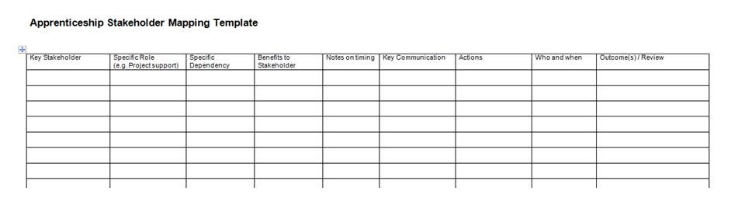

Type here…
(Or download the template from the Apprenticeship On-Boarding Web-page)

Section 10 - Progress Review Enter the contact information for your SHU Work Based Learning Coach and the date for your first Apprenticeship Progress Review, where you can raise any questions and begin to discuss this training plan and a list of key questions.

Type here…

Work Based Learning Coach from SHU:

Date of 1st Apprentice Progress Review:

Initial Questions:

- Q...

Document end

